Moses: an innovative way to model heterogeneity in complex social systems

Belinda Wu, Mark Birkin, Phil Rees, Alison Heppenstall, Andy Turner, Martin Clarke
School of Geography
University of Leeds
Leeds, UK
B.Wu@Leeds.ac.uk
Paul Townend, Jie Xu
School of Computing
University of Leeds
Leeds, UK

Abstract—Computer models can provide valuable groundwork for decision making. Complex social systems present great challenges for building such models. New technologies and techniques enable us to attempt more sophistication in complex social models than in the past. This paper presented an innovative approach to model a large number of heterogeneous individuals on a fine spatial scale to assist the demographic planning in UK.
Keywords-IBM, MSM, ABM, Complexity

Introduction
People, cities, and societies (and their past, present, and future) have always captured modellers’ fascination. Computer simulations and models now play an important role in reshaping our understanding of the complex social systems. Recent advance in new technologies and research methods enable us to attempt more sophistication in complex social models.
MoSeS (Modeling and Simulation for e-Social Science) is a research node of the National Centre for e-Social Science. MoSeS is an Individual Based Model (IBM) that synthesizes the UK population using the census samples and various distributed microdata and then projects individuals into the future from year 2001 to 2031 by simulating discrete demographic processes at a fine spatial scale using the resources of grid (cyber-infrastructure in USA) computing. Moses’ specific interest is in cities and regions, with an aim of building simulation models of interactions between individuals, groups, or neighbourhoods within metropolitan areas. Such simulations can form the basis of a wide range of applications in both e-research and public policy analysis.
This paper focuses on the hybrid modeling approach used in Moses that combines the strengths of both MSM and ABM to enable the modeling of a complex social system. While the modeling approach is grounded in the methods of MicroSimulation models (MSM), Moses also attempts to take advantage of the flexibility of constructing heterogeneous agents in Agent Based Models (ABM) to strengthen the modeling of interactions and behaviors. The ease of introducing unique rules for individual agents in ABM also helps us to improve the model when there is a knowledge gap or unavailability of data. In this paper we use Leeds as an example, a city in northern England with a population of 761,000, but the MSM is generalizable between local areas across the UK [1].

The Moses MSM
Since Orcutt first conceptualized and developed the micro-analytical research methodology to predict distributions of individual decision-making units [2], MSMs have quickly spread across the whole social science spectrum. Major MSM developments have been seen around the world during the past decades, including national models such as CORSIM for USA, DYNACAN for Canada, SVERIGE for Sweden, PENSIM for UK, APPSIM for Australia and for the whole Europe, EUROMOD [3].
Moses MSM provides a dynamic representation of key demographic events/transitions in a geographically identified population. Six important demographic processes modeled in Moses MSM: fertility, health change, mortality, migration, household formation and ageing. Occurrences of births, changes in individuals’ general health statuses, deaths, migration and household formation of the population at risk in such processes are driven by a set of probabilities that have been calculated and updated during the evolution of the population, using appropriate microdata and demographic trends. As the model is run in annual time increments, all survivors become a single year older at the end of each time step [3].
Previous literatures have pointed out the danger of ignoring unobserved heterogeneity on the estimation [4]. In order to study the real effects of policy changes, a good level of heterogeneity of the individual decision units is needed. Moses MSM attempts to capture individual heterogeneities from three aspects.
Large-scale MSMs can provide the response variability of the model to the same/similar level as the real system to study the effects of policy changes. Population size, both in terms of actors and their inter-relations and interactions, is important for such studies. Bigger groups create additional dynamics and consequently the levels of variability and stochasticity within the simulation model will change. Therefore a large scale model can help to account for unforeseen effects that are not modeled explicitly. Such features have been demonstrated in many national or multi-national MSM listed above. Moses attempts to model the evolution of the UK population (61 million in 2007) through interactive individuals during the period 2001-31.
As stated above, Moses attempts to capture the individual characteristics through a dynamic spatial MSM. Generally speaking, MSMs work in the principle to create microdata at a certain point of time and then generate future microdata on the basis of it [5]. As dynamic MSMs update “each attribute for each micro-unit for each time interval” [6], they feature more detailed and realistic simulation than static MSMs where no characteristics of the micro units are changed during the process. Due to its complexity, a national dynamic MSM in the past would typically take a national/multi-national team of developers to work over decades. With the aid of grid computing and e-research methods, we can draw on great computing power and a rich portfolio of datasets from other virtual organizations to run the model safely and efficiently [7].
Geography plays an indispensable role in influencing social progress and welfare, as individuals all have to live in a local area and be affected by what happens around us. Local characteristics and interactions needs to be modeled in order to enable the understanding of the whole picture of a social system. A spatial MSM simulates virtual populations in given geographical areas so that local contexts can be taken into account. The unique advantage of Moses over the national projections is an ability to disaggregate both socially and spatially. We provide more detail such as the household composition and health status, but we also provide very fine spatial details about these patterns by estimating probabilities at the smallest reasonable scale. For example, survival rates in the Leeds model are derived separately for each of 33 census wards (about 200 households in each ward), both genders, and 101 individual age groups (age 0 to 100+), giving a total of 6,666 individual parameters. The model runs in annual time increments and projection of mortality over 30 year involves the estimation of almost 200,000 individual mortality probabilities.
Mortality is a pretty straightforward process and only one probability is required for each individual. However, when more complex processes such as migration are modeled, multiple probability generation and updating are required for multiple stage modeling. Needless to say there will also be a need to simulate the following consequences. For instance, moving an individual from current position to another will lead to a series of updates at both locations. Handling all those processes, the application of MSM in Moses has demonstrated the strength of MSM in modeling such large complex social systems.

The Moses ABM
Although very useful with its list processing power with individual records and the capability to deal with real data, MSM has been found less flexible when we encounter the challenge of modeling the movement, interaction and behavior of the individuals within the system. Various interactions and behaviors among the individual decision making units in a social system can have a vital impact on population evolution and therefore need to be appropriately modeled to understand more complex processes or assist decision making. However, a MSM depends on good data about the important transitions experienced by individuals. Because of this dependency, MSM is less strong in modeling individual behaviors where realistic microdata are unavailable. The statistical nature of a MSM also makes it less flexible to model the heterogeneous behaviors of a large number of individuals. Moses attempts to strengthen the model on aspects of the interaction and behavior modeling by adopting a hybrid modeling approach, where agents are introduced into the MSM.
ABM is an alternative and effective approach that can model individuals as mobile agents through their interactions with each other and the environment that they live in according to their own built-in rules. ABM is very flexible to introduce heterogeneous agents with distinctive behaviors according to their unique rules. Such rules can be quite simple at the individual level, but simulation through a large number of agents can reproduce complex social phenomena at the macroscopic level, with leverage for unexpected patterns that are not intentionally modeled in the rules. Such a property makes it possible for an ABM to reflect the characteristics of a society more realistically and makes it a technique complementary to MSM in modeling a complex social system. Due to the flexibility of making simple individual rules, it is very useful in modeling behaviors of the population where knowledge and data is lacking and behaviors are not necessarily mathematically tractable [8]. Mobile agents in an ABM interacting with their environment and other agents seem to be an ideal partner to static, self-contained individuals in an MSM, especially in more complex demographic processes such as migration, where interactions and behaviors play an important role. Also such agents can have their own memories. This feature enables us to model the demographic processes where personal history has an important impact on demographic changes.
In this paper we investigate the usefulness of a hybrid modeling approach in a series of experiments where the MSM is combined with ABM to allow flexibility to capture the individual heterogeneities in their movements, interactions and behaviors. Particularly we experimented on three important properties of agents’: their ability to interact with their environment, to interact with others and to carry their own personal history around.
We chose student migrants as the sub-population in our first experiment, due to their distinctive migration patterns. Previous studies have recognized the difficulty of modeling student migration in small areas [9] [10]. In a city like Leeds, the frequent local migrations of about 30,000 university students make an important impact on local population structures. Though move frequently, students tend to only reside in certain areas, mostly around the universities, during the period of their study. Most of them then leave while other new students move in. Due to the replenishment of the student population each year, the population in such wards stays younger than that in other wards. As an ABM is very flexible in terms of constructing heterogeneous agents with different rules, we experiment with an ABM for the student migration process using hypothetical rules in a similar way to Schelling’s model on individual decisions to move and the composition of neighborhoods [11].
In Moses ABM, we recognize four types of agents/students: first year undergraduates, year 2 and 3 undergraduates, master’s students and doctoral students. Based on the above assumptions, we then apply some general rules to the students, in terms of the areas they stay in and the duration of their stay. Specific rules for individual groups vary according to their distinctive features. For example, a year two undergraduate student can stay in the area for two more years. They can then have the chance to continue studying towards a master’s degree for one more year or leave. While a master’s students can stay in the area for one year and then leave, or they may continue with a doctoral study for three more years. The typical interaction between the agents/students themselves would be to look for the fellow students in order to move to the area they stay in and the interaction with the environment would be checking if there is a vacancy in that area. An agent/student keeps searching in areas where their fellow students live until they find a vacancy to move in. The agent without success at the end of the search stays in the current area.
The simulation results of the student population using the pure MSM and using the ABM approach have been compared to the observed distribution of the student population. Through the implementation of simple rules at the individual level, the heterogeneity of student migration is captured. Instead of students almost evenly scattering around the whole city in the MSM, the hybrid model provides a much better reflection of the observed student population concentration around the city centre, close to the universities. Most students also leave upon completion of their study in the hybrid model as new students come into the area each year and are no longer growing old together with the rest of the population in the suburban areas as in the pure MSM (Figure 1). A fuller comparison can be found in Wu et al. [3].
Simulating geographically identified populations can demonstrate the local impact on the individuals to a degree. However, sometimes not only the current places, but where individuals came from or used to live also plays an important role in contributing to individual heterogeneities. For instance, if a person has worked as a miner all his life, his/her mortality/morbidity rates should not suddenly change a great deal just because he/she retired to a pleasant residential area. ABM can complement the MSM by retrieving personal histories with great ease. In this experiment, we explored 3 scenarios of mortality projections based on impact of: the current residence location, the first residence location in the system/birth places and the mortality dependent on personal migration histories. In the 1st scenario, all individuals are simulated in a MSM. Their survivals are determined against an age, sex and location specific mortality probability generated on the basis of local information about the current location of residence. An ABM approach is used in the 2nd and 3rd scenarios, where agents carry their own histories along with them and have to check on such histories to determine their mortality probabilities. In the 2nd scenario, the survivals are determined on the basis of the mortality rates of individual first residence location/birth places. In the 3rd scenario, we tried to model the impact of personal migration history on mortality. Mortality is projected on the basis of the mortality rates of the area where the individual stays the longest to date.
In the experiments, the whole population of Leeds has been simulated under the three assumptions for 30 years and the results of year 2031 are then compared spatially to assess the difference in the mortality distribution within the city. Although the distribution pattern of mortality is similar on the whole, the experiments still reveal some interesting variations in small areas. Unsurprisingly, the mortality projection based on origins in the 2nd scenario is more different from the projection based on current locations in the 1st scenario. While the projection based on individual migration history in the 3ird scenario demonstrates more similarity with the 1st scenario. However, interestingly we can see from the map that there tend to be a higher mortality in the more established suburban wards in the northern area of the city in first residence based projection than in the current residence based. In comparison, the majority residence based projection indicates a reduction of mortality than in the current residence based projection in the northern suburban areas, but indicates an increase of mortality in the traditionally less affluent areas in the south and east area around the city centre. Such findings demonstrate that personal history could have an important impact on mortality (Figure 2).
Empirical research on the relationship between limiting long-term illness and migration [12] established that the illness status of migrants is mid-way between that of their origin and destination locations. If this finding also applies to mortality, then a combination of all three scenarios may be needed to represent the mortality chances of migrant properly. We will continue improve the mortality projection in the light of such evidence. Needless to say, international migrants’ migration histories may also have a considerable impact on their health and mortality than local people. Although the mortality experiments discussed here are purely based on hypothesis due to the lack of data, it demonstrates that there are many more aspects of the population MSM which can be strengthened through the use of ABM techniques. Important elements of the model such as marriage behavior, fertility patterns and change in health status might all benefit in a similar way. Such explorations are not only just interesting experiments, but potentially can play a vital role in facilitating the decision making where the impact of personal history is required to be taken into account.

Conclusion
In this paper, we introduced the hybrid approach used in an ambitious social model Moses, which combines the strength of both MSM and ABM to model heterogeneity in a complex social system. Moses has faced the challenges of modeling large complex social system in a fine geographical scale, as well as attempts to capture the distinctive patterns of movement, interaction and behaviors of various sub-populations. Adopting the hybrid approach, we have achieved the goal of both the effective handling of large scale individual based system and extra flexibility to model various behaviors of sub-populations in different scenarios.
In the examples we described above, we deliberately chose the most straightforward processes and applied ABM with considerable simplification. However, the modeling of interaction, behavior and personal history impact can be significantly more complex with intelligent agents. For example, people can have much more complex interactions with others and their environment to make a decision or take an action based on their personal history or requirement during the household formation process. The examples discussed in this paper are simply used to demonstrate the potentials of the hybrid model.
As a demographic planning tool, Moses can monitor the evolution of population structures and various demographic change patterns on a fine geographical scale. This provides vital information for demographic planning/policy making. Moses can also benefit other public policy making or public service planning. For instance, the ageing trends in certain suburban areas may promote changes in health service and public transport service provision in order to enable easy access to such services for the old and frail in the area. The rich attributes captured in the system are also very useful in various policy analyses or research purposes.
The Moses hybrid model has provided a framework to enable the effective modeling of heterogeneous decision making units on a large scale, as well as adding the flexibility to introduce different modeling techniques to strengthen various aspects of the model. The model itself provides a useful tool in assisting decision making, exploring various “what if” situations and testing different hypotheses. As we have discussed above, the hybrid modeling approach demonstrates great potential in demographic modeling and we will continue trying to improve various aspect of this model using this approach to provide a better groundwork for decision making and predicting the future.

Acknowledgment
This research has been funded by the Economic and Social Research Council through the National Centre for e-Social Science (Hydra RES-149-25-0020; MoSeS RES-149-25-0034 and GENeSIS RES-149-25-1078).
Census output is Crown copyright and is reproduced with the permission of the Controller of HMSO and the Queen's Printer for Scotland. 2001 Census, Output Area Boundaries. Crown copyright 2003.
The British Household Panel Study data were originally collected by the Economic and Social Research Council Research Centre on Micro-social Change at the University of Essex, now incorporated within the Institute for Social and Economic Research. Neither the original collectors of the data nor the UK Data Archive bear any responsibility for the analyses or interpretations presented here.
2001 Census: Special Licence Household Sample of Anonymised Records (SL-HSAR) were deposited by the University of Manchester, Cathie Marsh Centre for Census and Survey Research. Although all efforts are made to ensure the quality of the materials, neither the original data creators, depositors or copyright holders, the funders of the Data Collections, nor the UK Data Archive bear any responsibility for the accuracy or comprehensiveness of these materials.

References
- Office for National Statistics (ONS) “UK population approaches 61 million in 2007”, News Release, 2008, available at: http://www.statistics.gov.uk/pdfdir/popest0808.pdf, last accessed 9/7/2009.
- G., Orcutt, J. Merz and H. Quinke, (eds.) Microanalytic Simulation Models to Support Social and Financial Policy. Amsterdam: North Holland, 1986.
- B.M. Wu, M.H. Birkin,and P.H. Rees, “A spatial microsimulation model with student agents”. Computers, Environment and Urban Systems 32: 440–453, 2008.
- J.M. Wooldridge, “Unobserved heterogeneity and estimation of average partial effects”, in D.W.K. Andrews and J.H. Stock (eds) Identification and Inference for Econometric Models: Essays in Honor of Thomas Rothenberg, Cambridge University Press, Cambridge, pp. 27–55, 2005.
- D. Ballas, D. Rossiter, B. Thomas, G Clarke, and D, Dorling, Geography matters: Simulating the local impacts of national social policies, the Joseph Rowntree Foundation, ISBN 1 85935 266 9, 2005
- S. Caldwell, “Static, Dynamic and Mixed Microsimulation”, mimeo, Department of Sociology, Cornell University, Ithaca, New York, 1990
- M. Birkin, A. Turner, B. Wu, P. Townend, J. Arshad and J. Xu, “MoSeS: A Grid-Enabled Spatial Decision Support System”, Social Science Computer Review. 0: 0894439309332295v1, 2009.
- F., Billari and A. Prskawetz (eds.) Agent-Based Computational Demography: Using Simulation to Improve Our Understanding of Demographic Behaviour, London/Heidelberg: Springer/Physica, 2003
- T. Champion, S. Fotheringham, P. Rees, G. Bramley and others, Development of a Migration Model. Office of the Deputy Prime Minister and the Stationery Office, London, ISBN/ISSN: 1 851125 83 3, 2002
- Baryla, E. A. & Dotterweich, D. “Student migration: do significant factors vary by region?” Education Economics, 9(3): 269–280, 2001
- T. Schelling, “Dynamic models of segregation”. Journal of MathematicalSociology, 1: 143–186, 1971.
- P. Norman, P. Boyle, and P. Rees, “Selective migration, health and deprivation: a longitudinal analysis”. Social Science and Medicine 60(12), 2755-2771, 2004.

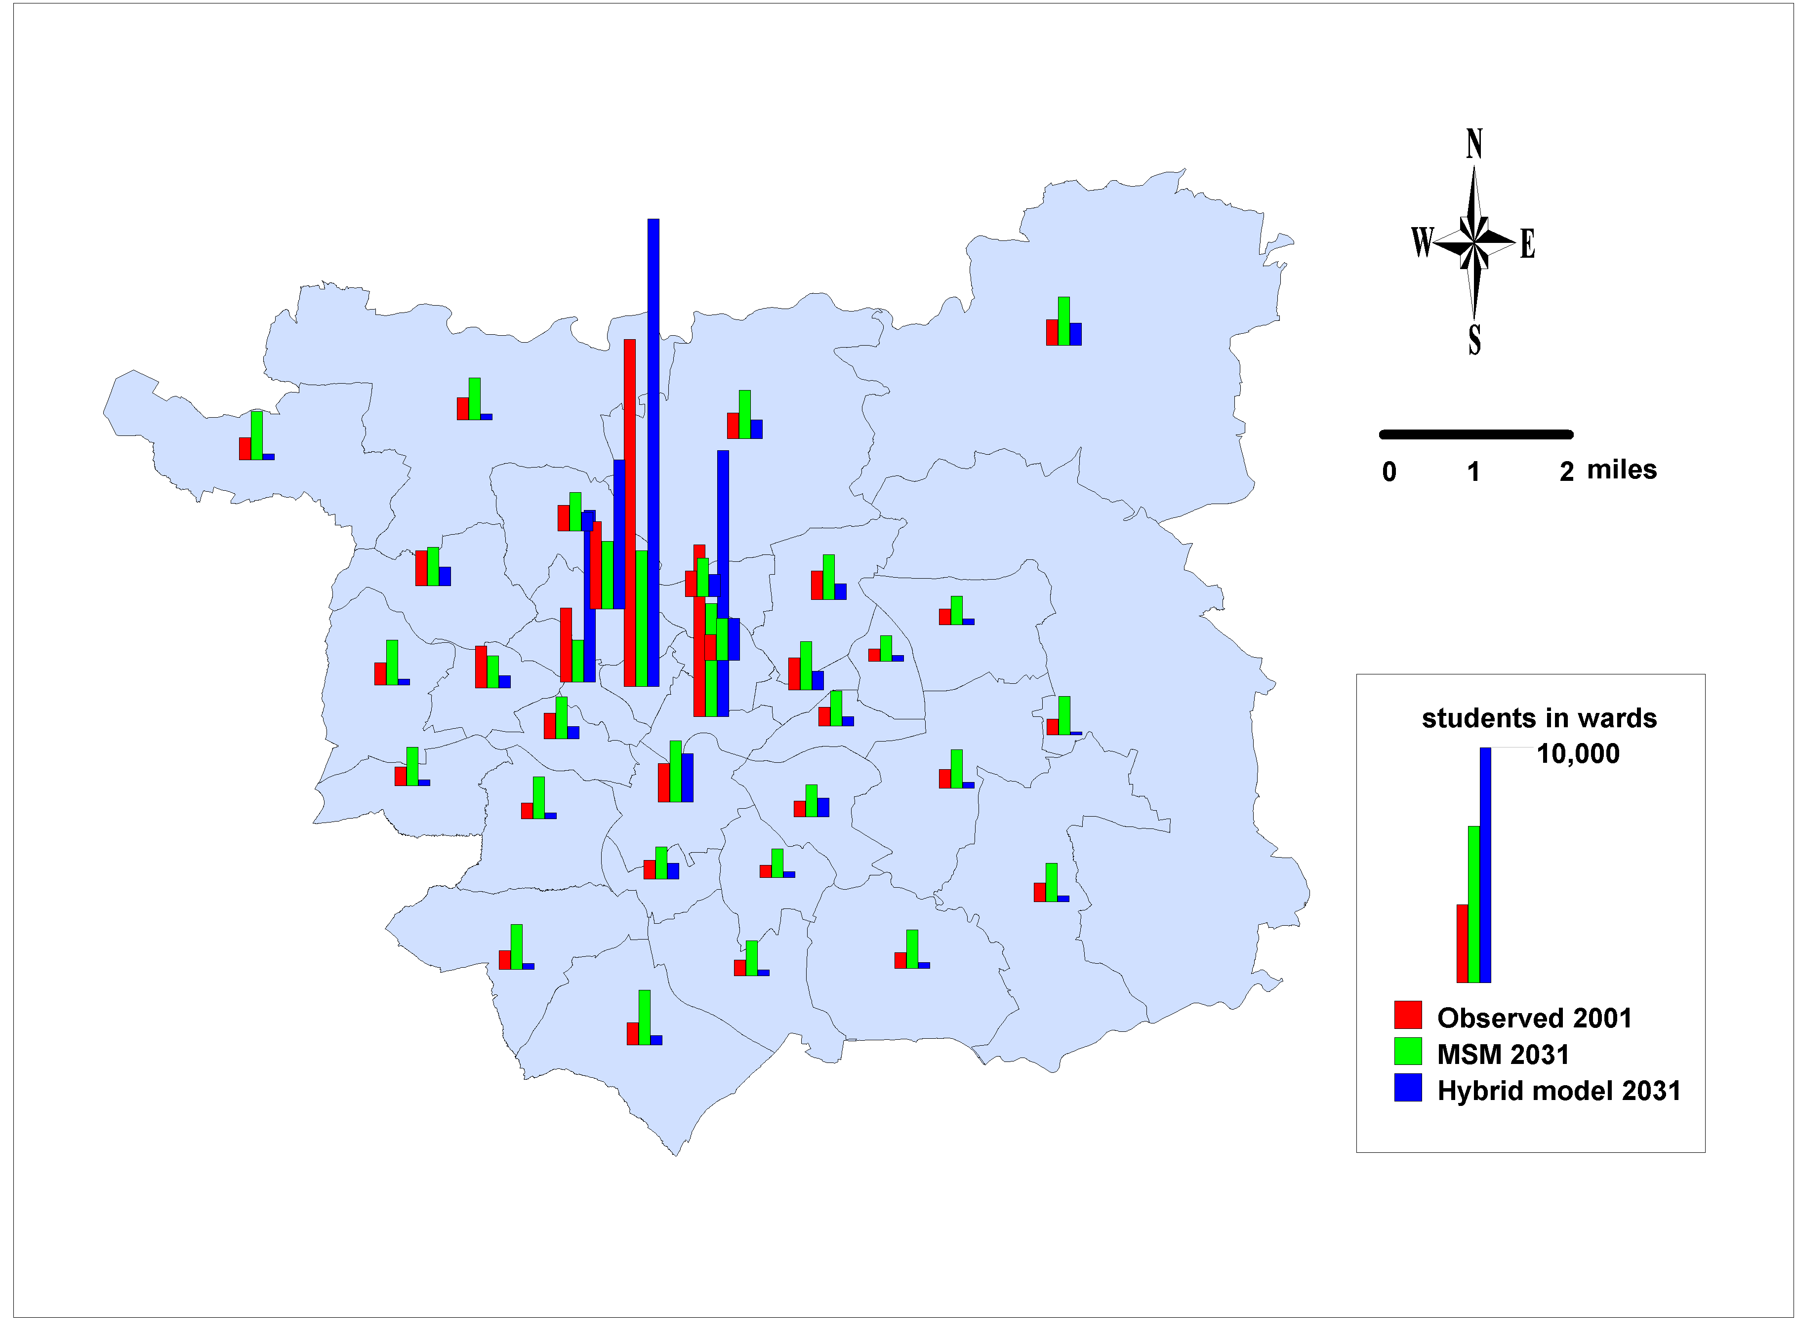
- Migration experiment: students in small areas 2001 and 2031
Source: Generated by the authors using 2001 Census statistics and ward boundaries. Crown copyright 2003

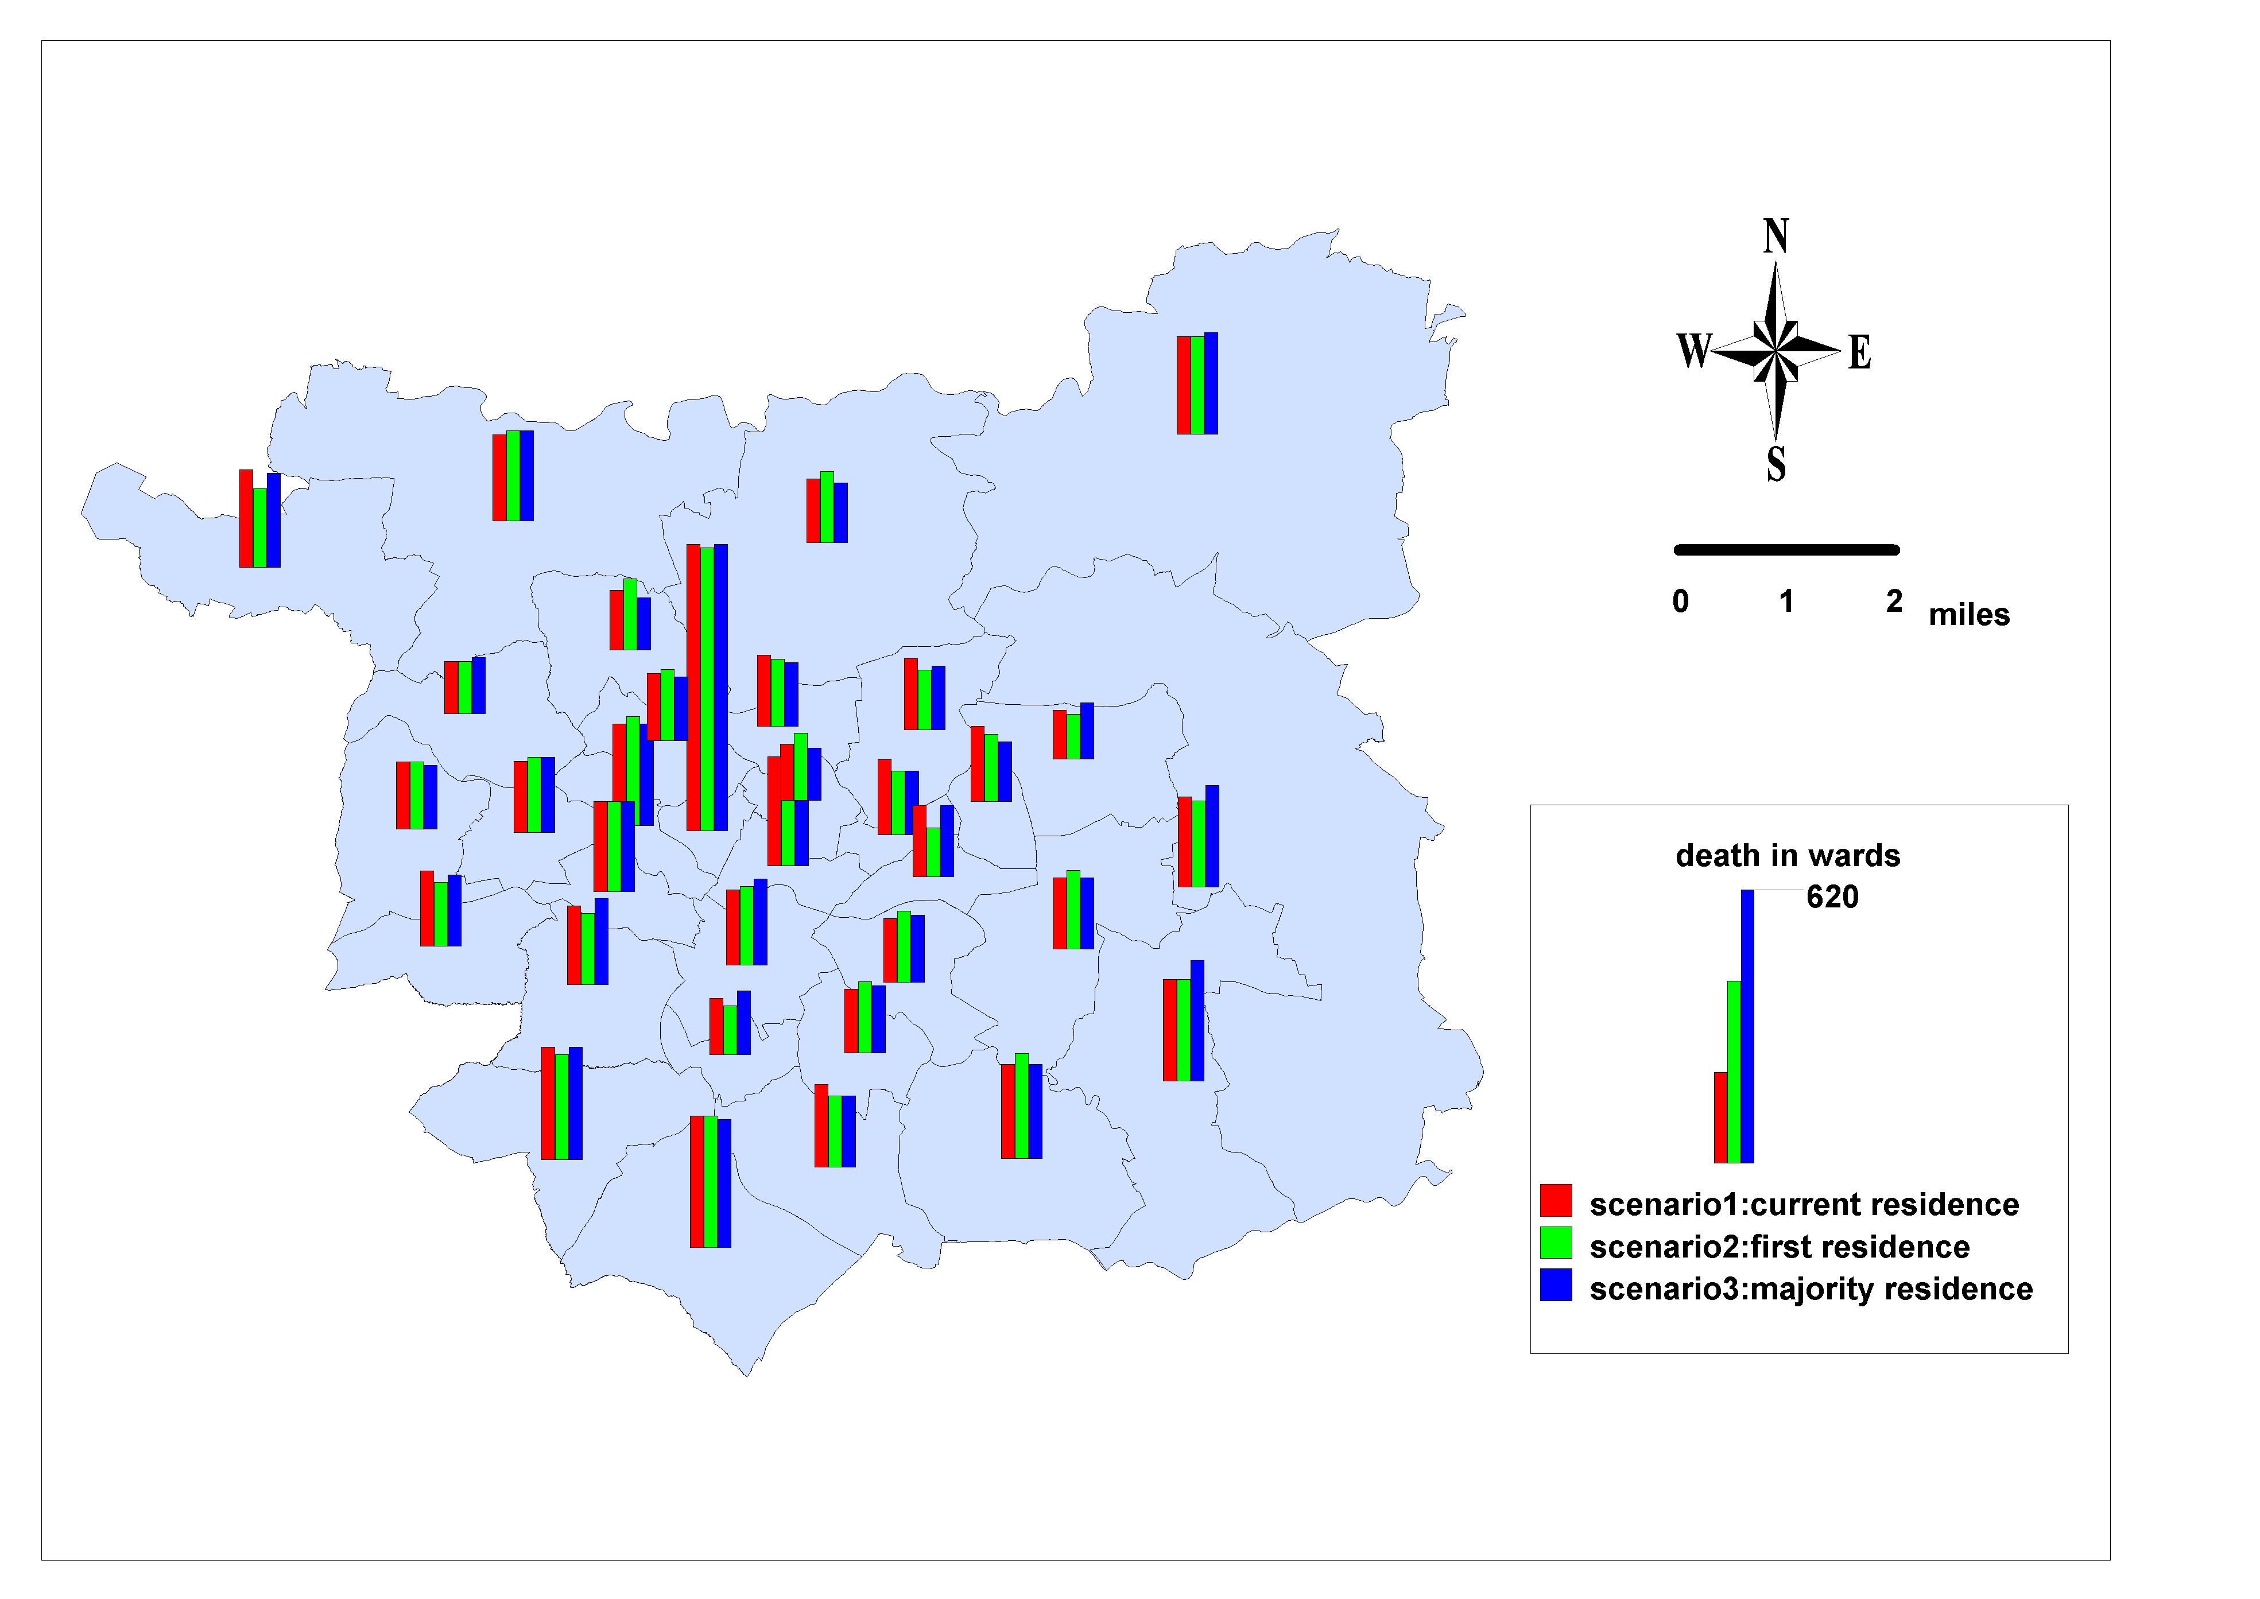
- Mortality experiment: deaths in small areas 2001 and 2031
Source: Generated by the authors using 2001 Census statistics and ward boundaries. Crown copyright 2003

