In the winter of 1993/4, the River Lavant caused considerable flooding in Chichester in West Sussex and the surrounding area.

Your task
It is impractical to prevent all flooding, and extreme events will always be likely to breach the best designed and constructed flood defences.
You will work in-groups to review the selection of a new flood defence scheme for Chichester. It seems certain that some kind of improved flood defence for Chichester and its environs is necessary, and in 1994 the NRA (later to become The Environment Agency) set about defining the process through which a scheme would be developed, approved and implemented. Specifically, for this task, you should consider what more information you might need (beyond what is included in these notes) to make a good decision about a new flood defence scheme, and develop and exemplify a template against which you would evaluate the various options. What factors should be considered, what weighting should they each receive?
This pack contains a detailed description of the flood event of 1993/4, some information about the hydrogeology of the river system, and outlines of some of the discussions that took place and reports that appeared after the flood event. It contains pointers to a number of issues that you will need to deal with, and a list of other resources that you may choose to access. It also contains an outline of the Environment Agency’s role in flood defence works.
The audience for your report is an Environment Agency planning group, wants to see your suggested template and support material presented as briefly and concisely as possible.

The Environment Agency’s Role
The Environment Agency came into being on 1 April 1996, because of the Environment Act 1995. The flood defence powers, duties, and responsibilities of the now obsolete National Rivers Authority transferred to the Agency.
In addition to flood defence, the responsibilities of the Agency include:
- Regulation of water quality and resources;
- Fisheries, conservation, recreation and navigation issues;
- Regulation of potentially polluting industrial processes;
- Regulation of premises which use, store, or dispose of radioactive material;
- Prevention of pollution by licensing and controlling waste management sites, waste carriers and brokers.

Rivers & Floodplains
Rivers and floodplains are fundamental parts of the water environment. Generally, their existence is a result of natural forces and processes, which must be respected if land drainage and flooding problems are to be avoided.
Rivers drain groundwater and surface water run-off from developed and undeveloped land. River channels have a limited capacity and when this is exceeded, flooding of the adjoining land (often known as the floodplain) occurs. Floodplains convey and store floodwater during such times.
Floodplain storage usually reduces the peak flood flow in the river. The effect of this is to reduce flood levels and the risk of flooding downstream. Additionally, floodplains assist in the conveyance of floodwaters, which can also have a bearing on flood levels and flood risks.
The flooding of floodplain areas is both natural and desirable, where it can occur without risk to human life. The effectiveness of rivers and floodplains to convey and to store flood water, and minimise flood risks, can be adversely affected by human activity, especially by development which physically changes the floodplain.
Before the Town and Country Planning system was established, there was little attempt to steer development away from rivers and floodplains. Indeed many of our settlements grew around river crossing points where transport routes converged. Consequently, the floodplains and channels of many major rivers became very restricted in urban areas. Inevitably, these restricted channels could not accommodate large storm flows and serious flooding of developed areas occurred. In some areas, it has been possible, at considerable public expense, to reduce the flood risk by engineering works, but this is not always a viable option.
Only towards the end of the 20th Century have we begun to properly value the natural function of floodplains and accept that it can be more cost effective to work with nature rather than to fight it. Current uncertainties over possible climate change and associated sea level rise make the need to safeguard floodplain areas particularly important.
Throughout England and Wales, a considerable amount of development has already taken place on the coastal floodplain as well as on river floodplains. Consequently, people and property in these areas are already at risk from flooding. This leads to pressure for new or improved coastal and river flood defences, with consequent long-term maintenance cost implications.
There is an ongoing programme of both Environment Agency and local authority flood defence works, which is regulated and mainly funded through the Department for Environment, Food and Rural Affairs, and the Welsh Assembly Government . These works are in many instances necessary to provide or to ensure the continuing existence of physical defences to protect development, which has taken place in floodplain areas.
Traditionally, floodplains have also been used for agricultural purposes. River levels were controlled to aid field drainage and to manage the frequency of flooding of water meadows, thus boosting crop yields. Nowadays, there is a need to consider the control of water levels through water level management plans to cater for the needs of a wide range of floodplain interests in a way that is both balanced and sustainable.
At many locations, the increasing recognition of the ecological value of floodplains together with changing agricultural policies are providing opportunities to re-establish the natural functions of floodplains. Much floodplain land is already recognised to be of high ecological value and many river valleys have statutory wildlife and conservation status. The Agency will encourage planning authorities to make use of the potential environmental, recreational and amenity opportunities which floodplains provide.

Flood Defence
The Environment Agency's flood defence function aims to reduce risks to people and the developed and natural environment from flooding from rivers and the sea.
In discharging its flood defence function, the Agency's concerns include:
- The natural catchment area of watercourses and rivers;
- The channels occupied by rivers and watercourses during times of normal flow;
- Floodplains and wash-lands which accommodate water during periods of flood and;
- Coastal floodplains, that is land at risk from flooding from the sea or tidal lengths of rivers, whether or not protected by sea defences.

Source: Extract from Policy and Practice for the Protection of Floodplains (Environment Agency January 1997). Look for updates on the Environment Agency web site: http://www.environment-agency.gov.uk/
Note that in some places in the following text, the National Rivers Authority (NRA) is referred to specifically. At the time of the flood event of 1993/4, the Environment Agency did not yet exist.

The Hydrogeology of the River Lavant
The River Lavant is fed from springs which rise in the South Downs above East Dean and elsewhere. The South Downs contain a major chalk aquifer, overlying impermeable clay. The River Lavant flows west, then south through a gap in the South Downs. There must once have been a major river flowing south here, and the area around Chichester (and all the way to the sea) consists of extensive alluvial gravel deposits. There is excellent hydraulic connection between the river and the ground water in the gravel, so that sometimes, the river may flow at East Lavant, and then disappear before Chichester.

Helpful Maps
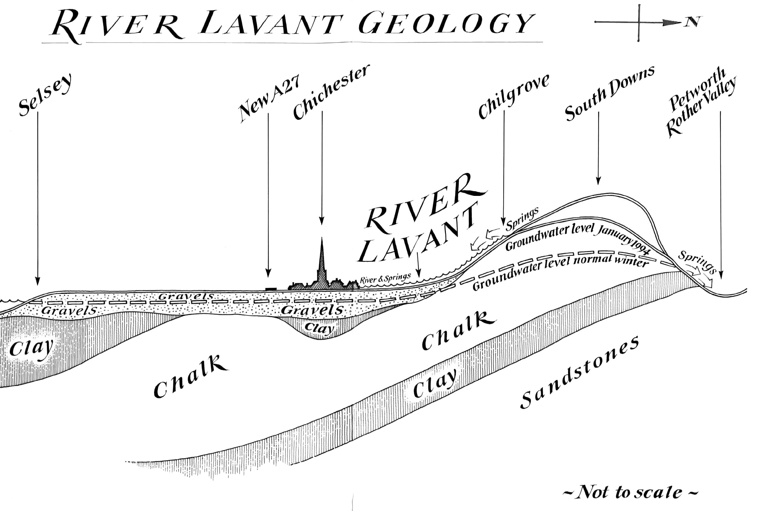
Ordnance Survey. Chichester and the South Downs, Bognor Regis and Arundel, sheet 197, 1:50,000, 1998 (Landranger series).
Ordnance Survey. Chichester, South Harting and Selsey, sheet 120, 1:25,000. 1998. (Explorer series)
Ordnance Survey. Arundel and Pulborough, Worthing and Bognor Regis, sheet 121, 1:25,000, 1998 (Explorer series)
Soil Survey of England and Wales. Soils of SouthEast England sheet 6, 1:250,000. 1983.
Geological Survey of Great Britain (England and Wales), Chichester and Bognor, (solid and drift), sheet 317/332, 1:50,000, 1996.
Institute of Geological Sciences, Wight, (solid), sheet 50’N - 02’W, 1:250,000, 1977.
Of interest if available:
Institute of Geological Sciences and Southern Water Authority. Hydrogeological Map of the South Downs and Adjacent Parts of the Weald, 1:100,000, 1978.
National Rivers Authority: Groundwater Vulnerability of West Sussex and Surrey, sheet 45, 1:100,000, 1995.
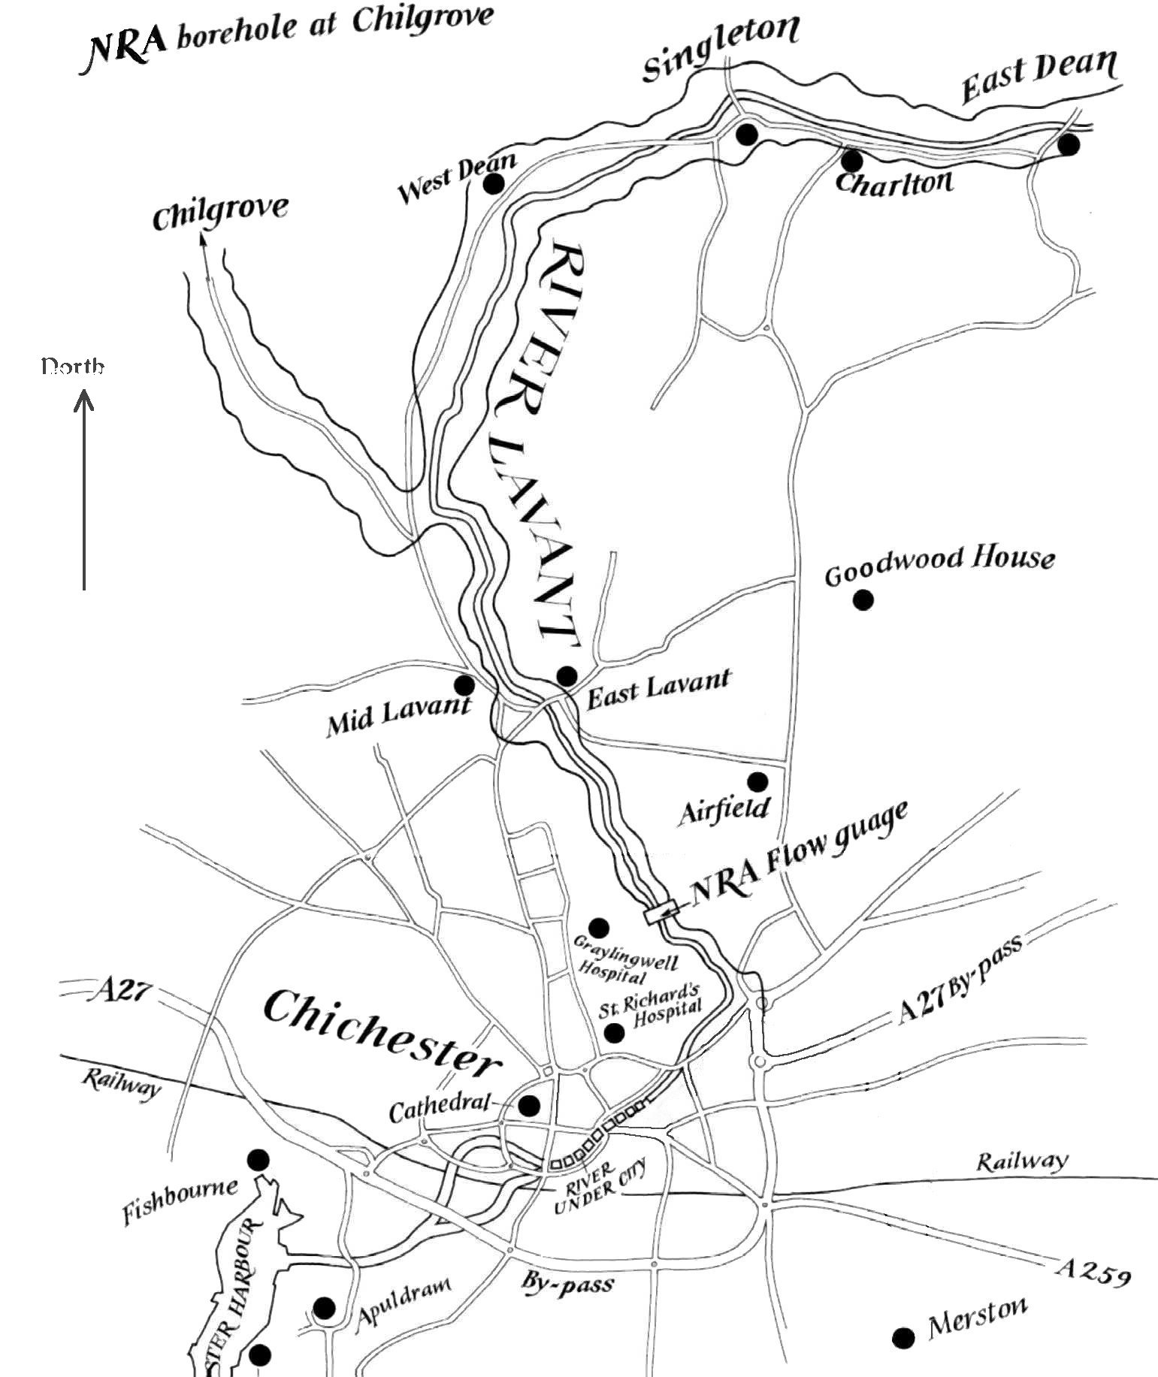

The 1993/4 Flood
In the decade prior to 1993, the River Lavant had no significant flow in most years - to the extent that local people had begun to bemoan its demise, blaming water companies for extracting too much water. Indeed, the levels of water in the chalk aquifer in the South Downs had been very low throughout the 1980s. There are two major ground level recording stations, at Chilgrove in the River Lavant catchment and at Compton in the Ems catchment. Chilgrove showed its lowest level since records began (1836) during the 1980s (34m OD).
However, by summer 1993, the aquifer had been fully recharged, and it was close to its long-term average level by 1 September 1993.
The autumn of 1993 was exceptionally wet, and heavy rain fell during the late autumn. Chilgrove showed 69m OD by late December, some 18m above average. Flow in the River Lavant was not significant until mid-December, but rose rapidly from 1.7m³s⁻¹ at the end of December.
The first flooding was recorded in late December at Church Farm Pit in the Westhampnett area, just north of the A27 by pass to the east of Chichester. This is not surprising, as there is excellent hydraulic connection between this pit and the bed of the River Lavant at Westhampnett. Flooding at Church Farm Pit indicates that ground water levels in the gravel beds are very high.
By 30 December, the River Lavant was running bank-full just above Westhampnett, and rainfall in the last 10 days of December totalled 76.4mm. The borehole at Chilgrove became artesian.
This diagram shows the location of flooding that occurred in the subsequent weeks. The Hornet area was flooded by Monday 3 January, and a further 30.9mm of rain fell on that day. By the evening of 5 January, Church Farm Pit (marked ‘lake’ in the diagram) had overtopped and the A27 bypass was flooding. The bypass was closed on 7 January.
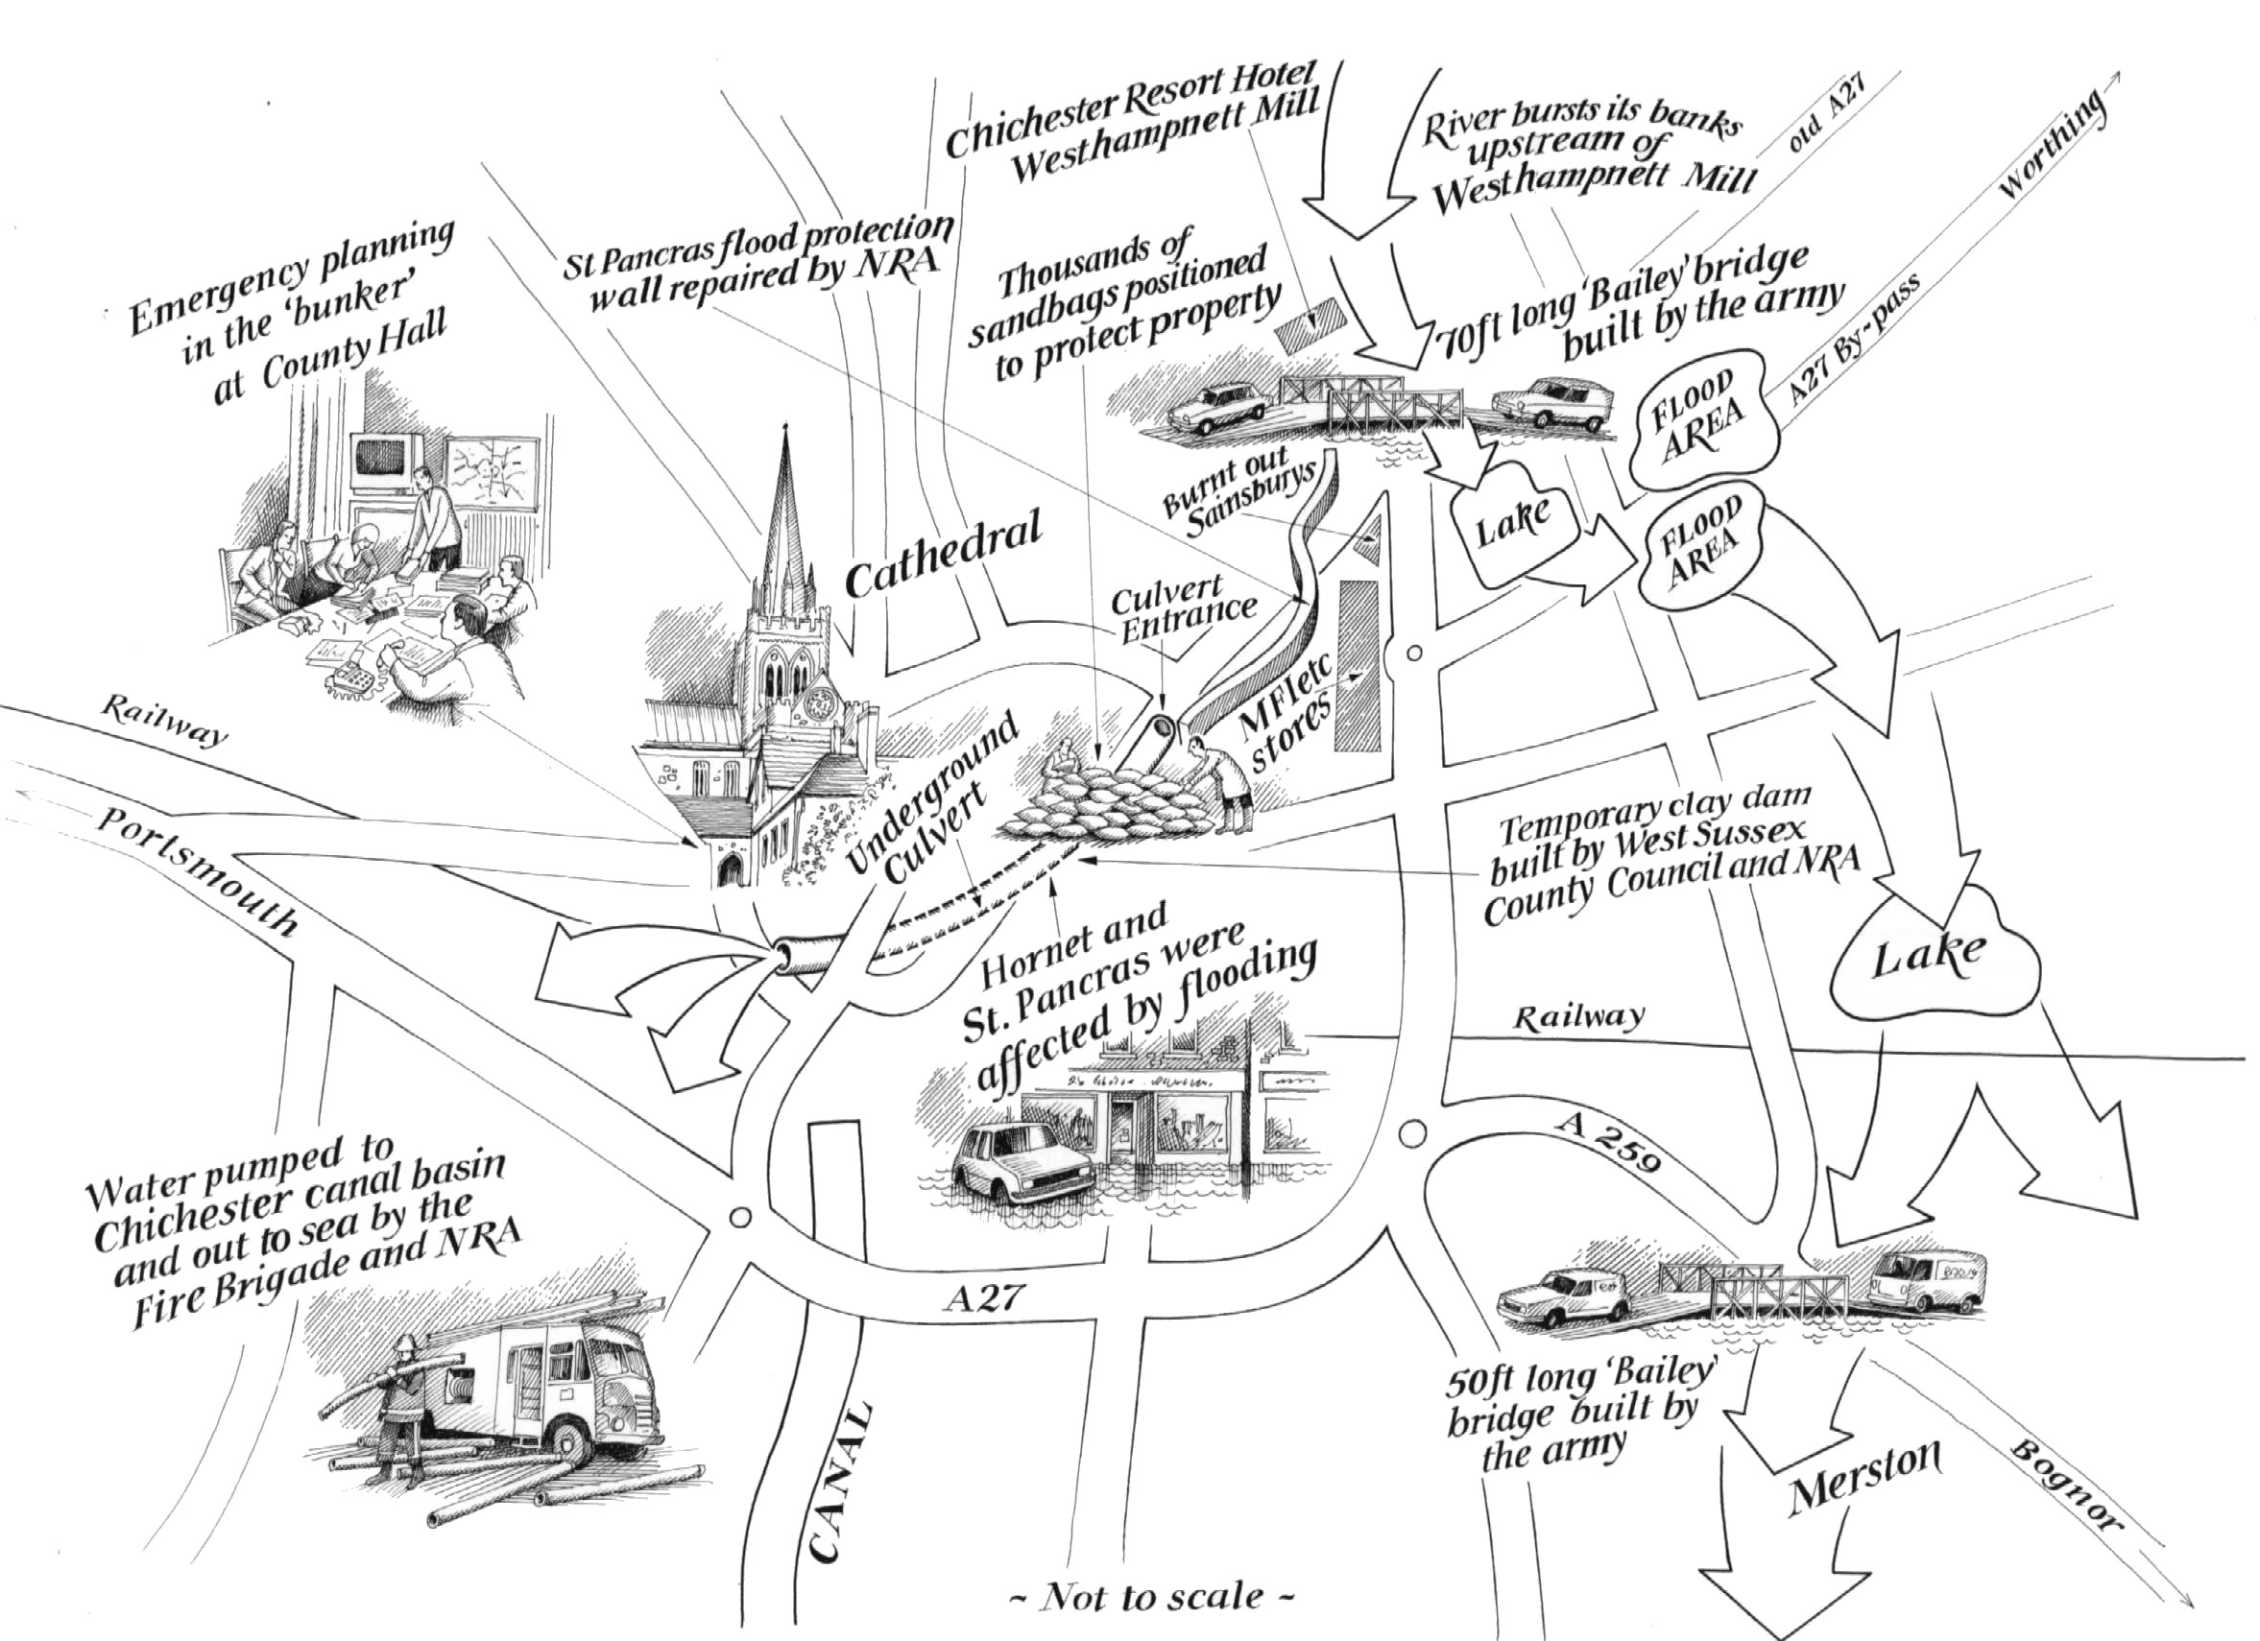
Areas in the upper catchment were also flooding, especially at East Lavant, Singleton, East Dean and Charlton. Sewage began to back up at Singleton.
On 8 January, flood water forced its way south across country, closing the A259 and flooding Shopwhyke and Merston.
The river flow gauge at Graylingwell recorded a flow of 7.1m³s⁻¹ on 12 January. Because the river began to flow extensively over the fields adjacent to the flow gauge, it is only possible to estimate the maximum flow rate at 7.9m³s⁻¹. The highest estimated ground water level at Chilgrove was 79.15m OD (estimated from measurements at Compton, there has always been excellent correlation between the two points). The maximum flow rate was small but the flooding remained for nearly 4 weeks because of the influence of the chalk aquifer maintaining these flows.
The culverts through the city of Chichester can probably handle flows of 4.0m³s⁻¹ at normal times. Because a temporary clay and sandpit dam was constructed at great speed just above the entrance to the first culvert, it actually took 5.3m³s⁻¹. This dam was built on a site that was being prepared for new housing (now occupied). Had the culvert failed, then over 1,000 properties would have been inundated within 30 minutes. The culvert flowed severely surcharged for over 3 weeks.

Rain continued to fall until Wednesday 19 January, and the flooding became more widespread. A Bailey Bridge was erected by the Army to open the A259 and another over the flooded road at Westhampnett. The extent of flooding on the A27 bypass to too great to be bridged, and for some days the only safe route from west to east was via the M25 south of London, a considerable diversion.
By the end of January the flood had subsided. 45 houses had been flooded in the upper catchment villages, as well as large areas of farmland and many local roads. Industrial and Commercial property to the east of Chichester were severely affected (widespread development had been permitted to the east of the city in the 1980s, much of this as a retail park). Another 45 houses were flooded in the Hornet and St Pancras areas of Chichester. South of Chichester, Oving and Merston experienced flooding, and the Pagham, Forebridge and Aldingbourne Rifes were swollen by out of channel flow from the River Lavant. Trains operated at reduced speed, since the stability of the railway embankment was threatened. Further farmland was flooded all the way to Pagham Harbour.
Early January 1994 saw some extreme weather conditions across much of Northern Europe. Near to Chichester, storms threatened the sea defences at Selsey Bill. Many other rivers burst their banks at the time, across the whole of England. Throughout the deluge, warnings were given that hose pipe bans in place in various parts of the country would not be lifted, as water reserves were still low.

There followed…
The NRA commissioned a report on the causes of the flood. This was researched and written by Posford Duvivier, a local firm of consulting engineers, and appeared in preliminary form in July 1994.
Before then, speculation began about what might be done to prevent a re-occurrence. Much attention focused on the idea of building a flood relief channel to take surplus flow south around Chichester to link up with the Chichester Canal. This might give substantial secondary benefits through improved local amenities. The Canal was in a poor state of repair, and such a flood defence scheme would give impetus to increasing leisure usage of the canal, with boats coming right into the Canal Basin in south-west Chichester.
Divers examined the culverts under Chichester, and established that they were in a ‘fair’ condition, but a more detailed examination was advisable when flows finally ceased.

The July 1994 Report
The first report, published in July 1994, showed that the extreme wet weather through the autumn and winter was the only major factor that could be pointed to as a cause of the floods. A whole series of issues may have had slight adverse effects, but were not thought to be major contributors. These included: a change in agricultural practice, gravel extraction activity, changes in water abstraction rates from the aquifer, and recent flood plain development.
This report estimated that the likelihood of a repeat event of the same magnitude was less than 1%, and that the costs incurred were of the order of £6 million.
However, it also estimated that a lesser flood event might well occur with a frequency of around 25 years (this is a 4% risk each year). It pointed out that if the culverts under the city became blocked or damaged that the consequences of flooding would have been substantially worse.

It considered the effect on ground water flows of the construction of the new A27 bypass road, and concluded that there were a number of smaller issues about its construction that had aggravated flooding, in particular that culverts beneath the road were not yet in use. However, the report also concluded that this had a relatively minor impact.
It concluded also that significant flow in the River Lavant is likely if Chilgrove records ground water levels above 69.5m OD, and there is subsequent heavy rainfall.
It recommended a flood alleviation scheme for Chichester is investigated, and a flood-warning scheme is developed for the River system as a whole.
The NRA commissioned a further report (again from Posford Duvivier) to investigate Flood Alleviation Options, which was produced in November 1994.

The Flood Defence Schemes

The November 1994 Report for the NRA
This report concluded that the maximum safe flow through the Chichester culverts was 4m³s⁻¹. On this basis, it is probable that the risk of flooding in any one year is 4% (a return period of 25 years).
It considered environmental issues. There are a number of Sites of Nature Conservation Importance (SNCI) and Sites of Special Scientific Interest (SSSI) nearby. Part of the upper catchment and the Fishbourne channel (the channel through which the Lavant flows west of Chichester) are designated as Areas of Outstanding Natural Beauty (AONB). There are many sites of archaeological interest.
This report identified a number of other flood relief schemes, besides the Canal proposal noted above. The list of possible flood defence schemes now included:
- Do nothing (meaning sustain the existing arrangements, and refurbish the Chichester culverts).
- Provide an improved channel through Chichester.
- Divert the Lavant onto a disused railway line north of Chichester.
- Provide a relief channel via the Pagham Rife to Pagham Harbour.
- Provide a relief channel via Chichester Canal to Chichester Harbour.
- Provide a relief tunnel beneath Chichester.

The Schemes in more detail

Do nothing (sustain existing arrangements)
There was no significant adverse environmental impact caused by the 1993/4 flood, and it is not expected that any future flood would have any either. Indeed, the population of birds visiting Pagham Harbour increased dramatically following the flood. More frequent flooding may provide an improved ecological resource. The cost of the flood event was calculated at £6 million made up as follows: Direct Damage £2 million; Business Loss £0.6 million; West Sussex County Council Costs: £1.9 million; NRA Costs: £0.4 million and Road Closure Cost: £1.1 million.

Deciding on this option is not a zero cost choice. The culverts through the City must be refurbished as necessary in the future, since they are clearly susceptible to future failure, and if they became blocked, the damage caused by a future similar flood event would probably cost in excess of £16 million. Immediate repair works on the culverts have been carried out since the 1994 flood, and annual maintenance is necessary.
Some other small works are needed elsewhere on the river, stabilising existing fragile structures, and removing one or two bridges that unnecessarily restrict flow in the river channel.

Provide an improved channel through Chichester
The existing culverts would need to be nearly doubled in size. There are a number of old and listed buildings over the existing culvert, so such work would have to be confined to deepening the channel.
This means extensive piling and underpinning to support the buildings. There would need to be considerable archaeological scrutiny of such work. There would be some disruption to traffic in the city, and some buildings would have to be demolished. No costs have been calculated for this option, but could be in the region of £10 million.

Divert the Lavant onto a disused railway line
This bypasses the city with a minimum of disruption and impact. The diversion point would be some 3km upstream of Westhampnett at Mid Lavant. The railway runs south from Mid Lavant, curving southwest around the north fringe of the city. The track may need excavating to a depth of up to 10m for part of the first 7km, as the track rises.
The track at Mid Lavant is about 1.4m above riverbed level, so pumping would be necessary to lift water into the relief channel. An aqueduct would have to be constructed above Newlands Lane. There is congestion where the line crosses the Fishbourne Road, and some services may need moving and two houses may have to be demolished.
The outfall into the Fishbourne Channel would be subject to tidal flooding, and a second pumping station would be needed. There are archaeological considerations as the existing channel west of Chichester appears to run alongside an embankment of ancient origin, and this would need to be modified. Fishbourne Meadows is an SNCI, and water level impacts may damage the meadow ecology. Chichester Harbour would receive the flow, and this may affect an SSSI consisting of reed beds and saltings.
No costs have been calculated for this option, but these could be of the region of £8 million.

Relief channel via the Pagham Rife to Pagham Harbour
A controlling structure would be needed just north of Westhampnett Mill, probably a side weir. New bridges and culverts would be needed to convey water into Church Farm Pit at Westhampnett, crossing an old Roman road. Flow would be channelled to a nearby pit, and thence across country to the Forebridge Rife south of Merston. There is a possible problem with leaching from back-filled pits near to Church Farm Pits.
The channel would slice through features of a suspected Iron Age or Roman settlement near Old Place Farm, just north of Westhampnett Mill. There is another similar settlement in Shopwhyke Park, near to the second water filled gravel pit. The channel would be diverted around the village of Merston (rather than passing through it as it does now). South of the B2166, no major channel works would be carried out, save the construction of embankments to protect key structures and property (the sewage works, a caravan park, a nursery and several houses). The channel would be allowed to flood onto the floodplain.
Pagham Harbour was reclaimed in 1876, and part developed into agricultural land behind an artificial shingle spit. Over the next 30 years, the area behind the spit built up through natural sedimentation. In 1910, storms breached the spit, and the area again became tidal. It still is. The harbour is designated an SSSI, specifically for its importance as a wintering site for wildfowl and waders.
The area behind the harbour is predominantly agricultural (some lies below high tide level) and is protected by a sea wall. The Pagham Rife is a meandering channel, owing more of its shape to its estuarial history than to fresh water flow. The channel slope is very low, with low flow rates. It was once an inter-tidal area, and the locations of a number of creeks can still be seen in the topography.
If this relief channel is selected, any floodwater would find its way to the old inter-tidal zone behind the sea wall at Pagham Harbour, and this would flood the lower section of the floodplain. A new gravity outfall structure capable of allowing flow rates of 16m³s⁻¹ would be needed to replace the existing outfall structure. This allows fresh water to flow into the harbour under gravity at low tide states, but prevents flow of seawater in the other direction.
This scheme utilises the natural fall of the land. It is likely that the Lavant originally followed this course but was then diverted around Chichester’s city walls for defence or water supply, possibly in Roman times.
Note that this scheme also provides a means to control local flooding at Church Farm Pit, which has been a repeating minor problem in the recent past. The Pagham Rife option has a discounted cost of £4.24 million

Relief channel via Chichester Canal to Chichester Harbour
The Chichester Canal runs south from the southern outskirts of the city to the village of Hunston, where it turns west to join Chichester Harbour. It was abandoned in 1928, and purchased by West Sussex County Council so that could secure the crossings and develop the recreational amenity potential of the canal.
At present, the canal is an important element of the local environment, due to the open water, reed bed and terrestrial habitats it contains. There is strong local interest in restoring it to navigation, which is estimated to cost £2 million, and which would reduce significantly were it also used as a flood alleviation scheme.
An application for Lottery funding for redevelopment of the canal has been turned down.
The first part of this channel would be identical to the Pagham Rife option as far as the railway on the Forebridge Rife. Once past the railway, the flow would be diverted westwards to discharge into Vinnetrow Lake. Flow would pass through a series of existing lakes currently used and stocked for trout fishing. These lakes currently drain to the southeast. Some fish loss might be inevitable during times of high flow. The channel would connect with the canal just north of Hunston. The canal needs considerable work to remove reeds and silt and in places raise its bank to accommodate the additional flow. This scheme takes floodwaters across the gradient and requires major engineering works around the Southern Leisure Lakes to protect nearby property.
It is possible that there will be intermittent small effects on the SNCI at Leythorne Meadows due to water level changes. The work on the canal, whilst not being sufficient to allow increased navigation, would damage reed bed habitats currently used by Reed and Sedge Warblers. There may be archaeological issues in the farmland between Vinnetrow Lake and Hunston.
This scheme too allows for control of local minor flooding at Church Farm Pit. The discounted cost of the scheme is £5.1 million

Relief tunnel beneath Chichester
It should be possible to drive a tunnel within the London Clay layer 10m beneath Chichester for almost its entire length. The inlet shaft could be sited in what is currently waste ground at the south side of the A27 bypass. The tunnel could be constructed by a tunnel-boring machine, and lined with pre-cast concrete segments. The channel at the southern end of the tunnel would pass through an AONB. There is not likely to be any archaeology at the depth indicated.
The discounted cost of the tunnel scheme is £7.3 million
The November 1994 report for the NRA listed all the construction features needed in preparation for tendering for whichever scheme was eventually chosen. The favoured scheme was the Pagham Rife relief channel. It should be noted that the money to build any such scheme depends on grant aid from the Ministry of Agriculture, Fisheries and Food (MAFF). MAFF has strict rules about evaluating such schemes with considerable attention focusing on economic costs and benefits.

After 1994
The third phase of development involved commissioning a detailed construction plan for the Pagham Rife route in preparation for a planning application. This was due for publication in late 1998. In the meantime, a variety of local viewpoints were expressed, a selection of which are summarised here.
Pagham residents have expressed concern that their views were being ignored, and that they were being asked to submit to changes that might threaten their safety. They would prefer the canal option. They are particularly concerned about a possible rise in groundwater levels locally that may cause back flow in the sewer system.
A new proposal appeared for a light railway built in such a way that it would also be an emergency flood relief channel. This would also allow the extraction of gravel from a new proposed pit currently prohibited because of a lack of rail access, and take millions of tons of gravel off local roads.
Concern has been repeatedly expressed about the risk of flooding to new proposed retail parks to the east of Chichester, considered vital to the area’s economy. The Environment Agency is objecting to a number of proposed developments on flood plains in the area.
The Council for the Protection of Rural England has expressed concern about the impact of gravel extraction near Chichester on the natural ground water flows from the South Downs to the sea.
Comment has been made that the significant investment needed to provide flood relief should be linked to private funding of new amenities, and that this would make the canal option considerably more viable. It is clearly the most desirable option. “… It is nonsense to have a penny pinching approach to the control of water flows in the area.” “A canal scheme could potentially attract millions of pounds of investment… probably more than covering the cost of what needs to be done.” The Environment Agency is forbidden under current rules from considering possible commercial factors.
Chichester Harbour Conservancy has expressed concern that the harbour would be irretrievably altered if floodwaters were channelled to the harbour.
Chichester Chamber of Commerce strongly supports the canal option, and believes the work must be completed as speedily as possible to protect the city.
Land at Hermitage has been earmarked for housing - there is a one in 100 chance of it flooding in any one year. One local resident commented: “That is absolute rubbish… it was flooding at my neighbours whilst the council were debating this. It floods half a dozen times a year with the very high tides. I just think there is real irony in reading about this decision whilst watching the water rise around my neighbour’s car!”

